16th July 2025

An Coimisiún Pleanála
64 Marlborough Street,
Dublin 1

Re: Ballina Flood Relief Scheme – Compulsory Purchase Order No. 01 of 2025

Dear Sir/Madam

I refer to the above matter.

This CPO application relates to the Planning Application submitted for Ballina Flood Relief Scheme in accordance with Section 175(3) of the Planning & Development Act 2000, as amended – reference; ABP-322329-25

Enclosed are the following documents:

- Deposited Drawings (2No. sets)
- Compulsory Purchase Order No. 01 of 2025.
An electronic copy of the above documentation is also submitted to An Coimisiún Pleanála

The statutory public notices specify the times and places at which and the period (not less than 6 weeks) during which plans and particulars of the CPO application may be inspected. They also invite submissions or observations to the Board during the specific period. In this case, submissions or observations must be made to the Board no later than 17:00 hours on 28th August 2025.

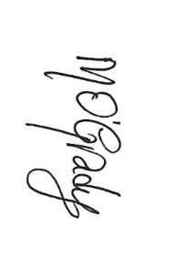
Yours Sincerely,

______________

Michael O’Grady,
Project Engineer.
Ballina Flood Relief Scheme.

